**UNIT - V**

**Syllabus:** Morphological Image Processing

Preliminaries, dilation, erosion, open and closing, hit or miss transformation, basic morphologic algorithms.

**Introduction:**

* The word morphology refers to the scientific branch that deals the forms and structures of animals/plants.
* Morphology in image processing is a tool for extracting image components that are useful in the representation and description of region shape, such as boundaries and skeletons.
* The morphological operations can be used for filtering, thinning and pruning.
* The language of the Morphology comes from the set theory, where image objects can be represented by sets. For example an image object containing black pixels can be considered a set of black pixels in 2D space of Z2.where each element of a set is a tuple (2-D vector) whose coordinates are the (x,y) coordinates of a black (or white depending on convention) pixel in the image.
* Gray scale digital image can be represented as sets whose components are in Z3. In this case two components of each element of the set refer to the coordinates of a pixel, and the third corresponds to its discrete gray level value.
  + 1. **Preliminaries**

**Some Basic Concepts form Set Theory:**

* + - Let A be a set in Z2, If a= (a1, a2) is an element of A, then we write a∈A
    - Similarly, if a is not an element of A, we write a∉A
    - The set with no elements is called the null or empty set and is denoted by the symbol Ø.
    - When we write an expression of the form C={w|w = -d, for d∈D} we mean that set C is the set of elements w, such that w is formed by multiplying each of the two coordinates of all the elements of set D by

-1.

* + - If every element of a set A is also an element of another set B, Then A is said to be a subset of B.
    - If every element of a set A is also an element of another set B, then A is said to be a subset of B, denoted as
    - The union of two sets A and B, denoted by 
    - The intersection of two sets A and B, denote by  {p|p ∈ A and p ∈ B}
    - The sets A and B are said to be Disjoint or mutually exclusive if they have no common elements, denoted by 
    - The complement of a set A is the set of elements not contained in A



* + - The difference of two sets A and B, denoted A -B, is defined as

We see that this is the set of elements that belongs to A, but not to B

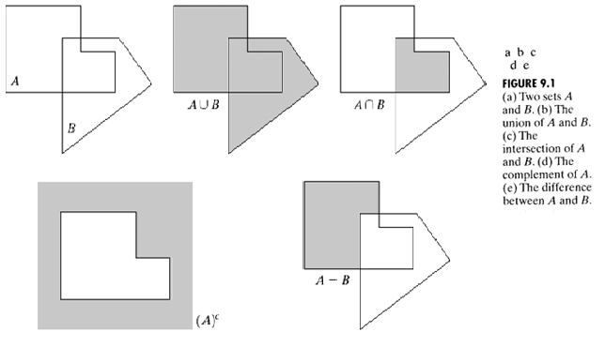

* + - The reflection of set B, denoted B^ ,is defined as

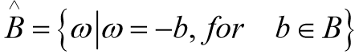

* + - The translation of set A by point z = (z1,z2), denoted (A)z is defined as



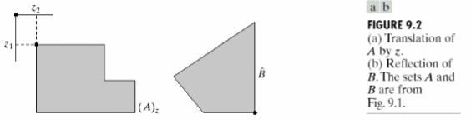

* + - Set reflection and set translation are used to formulate operations based on so-called structuring elements.

**Logic operators involving Binary images:**

* + - The main logic operators used in image processing are AND, OR and NOT (COMPLIMENT). These properties are summarized in the following table9.1. These operations are functionally complete in the sense that they can be combined to form another logic operation.
    - Logic operations are performed on a pixel by pixel basis between corresponding pixels of two or more images ( except NOT, which operates on the pixels of a single image)
    - Basic AND operation of two binary variables is 1 only when both variables are 1, the result at any location in a resulting AND image is 1 only if the corresponding pixels in the two input images are 1.

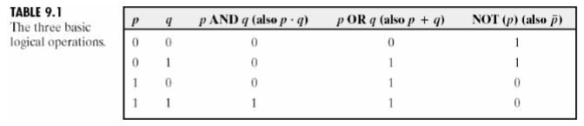

* + - The following figure shows the various examples of logical operations involving images, where black indicates a binary 1 and white indicates a 0.
    - The XOR (exclusive OR) operation yields a 1 when one or the other pixel (but not both) is 1, and it yields a 0 otherwise. This operation is unlike the OR operation, which is 1 when one or the other pixel is 1, or when both pixels are 1.
    - NOT-AND operation selects the black pixels that simultaneously are in B, and not in A.

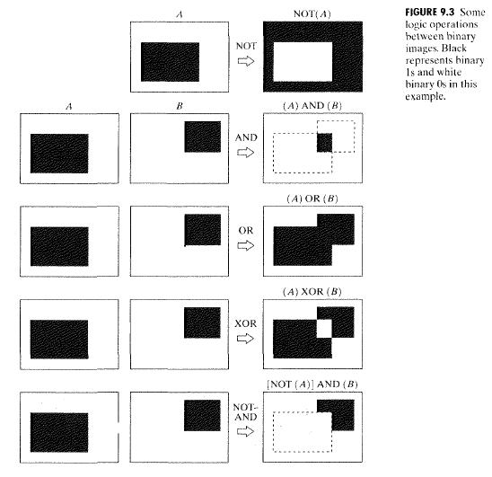

* + 1. **Dilation and erosion**
* Dilation and erosion are basic morphological processing operations. They are defined in terms of more elementary set operations, but are employed as the basic elements of many algorithms.
* Both dilation and erosion are produced by the interaction of a set called a structuring element with a set of pixels of interest in the image. The structuring element has both a shape and an origin.

**Dilation:**

* With A and B as set in Z2, the dilation of A by B, denoted A B, is defined as

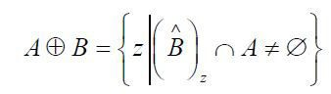

* This equation is based on Reflection of B about the origin, and shifts the reflection by z.

The dilation of A by B then is the set of all displacements, z, such that B^ and A overlap by at least one element.

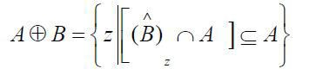

* Set B is commonly referred to as the structuring element in dilation.
* Although dilation is based on set operations, where as convolution is based on arithmetic operations, the basic process of “flipping” B about its origin and then successively displacing it so that it slides over set A is analogues to the convolution process.
* EX: In the following figure 9.4(a) shows a simple set 9.4 (b) shows a structuring element and its reflection(The dark dot denotes the origin of the element). In this case the structuring element and its reflection are equal because B is symmetric with respect to its origin. The dashed line in figure 9.4(c) shows the original set for reference, and the solid line shows the limit beyond which any further displacements of the origin of B^ by Z would cause the intersection of B^ and A to be empty. Therefore, all points inside this boundary constitute the dilation of A by B.
* Figure 9.4(d) shows a structuring element designed to achieve more dilation vertically than horizontally figure 9.4(e) shows the dilation achieved with this element.

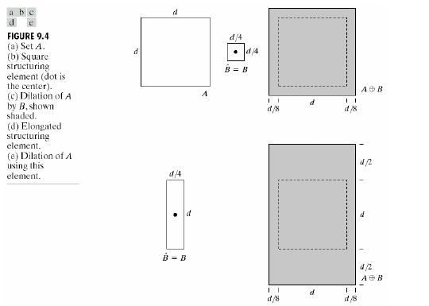

* + One of the simplest applications of dilation is for bridging the gaps.
  + Given the following distorted text image where the maximum length of the broken characters is 2 pixels. The image can be enhanced by bridging the gaps by using the structuring element given below:



**Erosion:**

* + Given A and B sets in Z2, the erosion of A by structuring element B, is defined by:



* + The erosion of A by structuring element B is the set of all points z, such that B, translated by z, is contained in A.

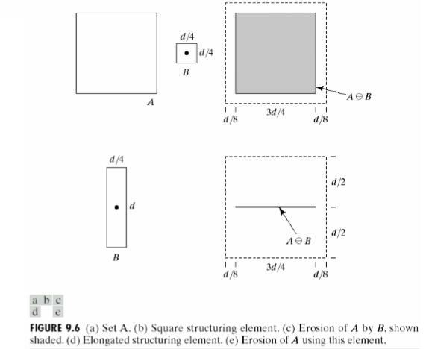

* + Set A is shown as a dashed line for reference in Fig9.6(c). The boundary of the shaded region shows the limit beyond which

further displacement of the origin of B would cause this set to cause being completely contained in A. Thus, the locus of points within this boundary constitutes the erosion of A by B.

* + Erosion and dilation are duals of each other with respect to set complementation and reflection

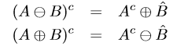

* + Duality property is especially useful when SE is symmetric with respect to its origin so that Bˆ = B
  + Allows for erosion of an image by dilating its background (Ac) using the same SE and complementing the results

Proving duality:

* + Erosion can be written as

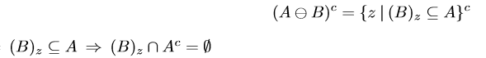

* + So, the previous expression yields



* + The complement of the set of z’s that satisfy (B)z ∩Ac = ∅ is the set of z’s such that (B)z ∩Ac != ∅
  + This leads to



* + 1. **Opening and Closing**

As we have seen, dilation expands an image and erosion shrinks it. Opening generally smoothes the contour of an object, breaks narrow isthmuses, and eliminates thin protrusions. Closing also tends to smooth sections of contours but, as opposed to opening, it generally fuses narrow breaks and long thin gulfs, eliminates small holes, and fills gaps in the contour.

The process of erosion followed by dilation is called **opening**. It has the effect of eliminating small and thin objects, breaking the objects at thin points and smoothing the boundaries/contours of the objects.

Opening of a set A by se B, denoted by A◦B, is defined by



Erosion of A by B, followed by a dilation of the result by B is **Opening A by B.** The opening of A by the structuring element B is obtained by taking the union of all translates of B that fit into A.

The opening operation can also be expressed by the following formula:



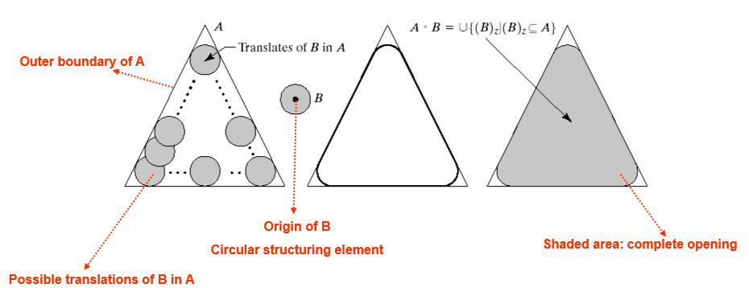

The process of dilation followed by erosion is called **closing**. It has the effect of filling small and thin holes, connecting nearby objects and smoothing the boundaries/contours of the objects.

Closing of a set A by se B, denoted by A•B, is defined by



Dilation of A by B, followed by the erosion of the result by B is **Closing A by B.** The closing has a similar geometric interpretation except that we roll B on the outside of the boundary.

The opening operation can also be expressed by the following formula:

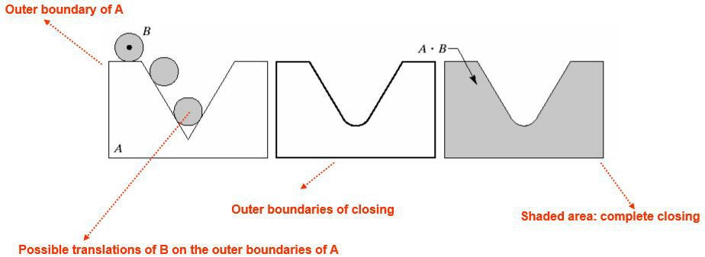

The following figure 9.10 illustrates the opening and closing operations.

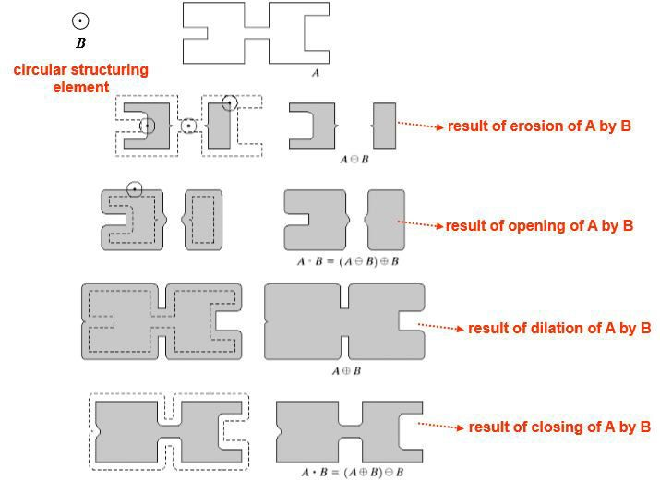

As in the case of dilation and erosion, opening and closing are duels of each other with respect to set complementation and reflection. That is,



Opening operation satisfies the following properties:

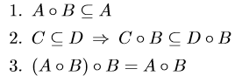

Similarly, closing operation satisfies:

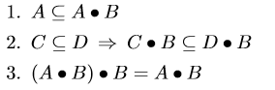

In both the above cases, multiple applications of opening and closing have no effect after the first application.

Example: Removing noise from finger prints The background noise was completely eliminated in the erosion stage of opening because in the case all noise components are physically smaller than the structuring element.

We note in Fig 9.11(d) that the net effect of opening was to eliminate virtually all noise components in both the background and the fingerprint itself.

However, new gaps between the finger print ridges were created. To counter this undesirable effect, we perform dilation on the opening.

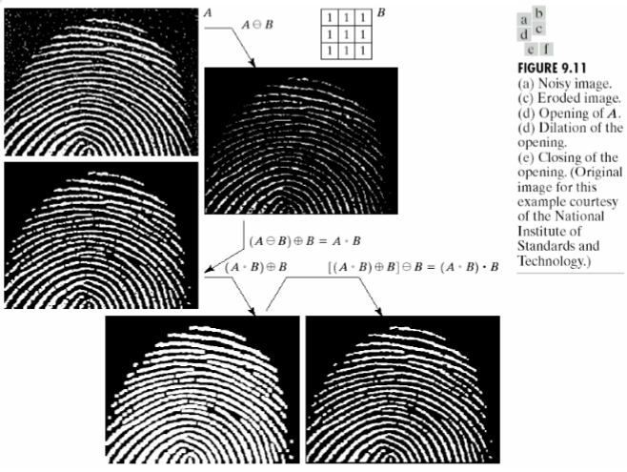

* + 1. **Hit-or-Miss Transform (Template Matching)**

Hit-or-miss transform can be used for shape detection/ Template matching. Uses the morphological erosion operator and a pair of disjoint SEs. First SE fits in the foreground of input image. Second SE misses it completely. The pair of two SEs is called *composite structuring* element.

Given the shape as the structuring element B1 the Hit-or-miss transform is defined by:



Where B2 =W-X and B1=X. W is the window enclosing B1. Windowing is used to isolate the structuring element/object.

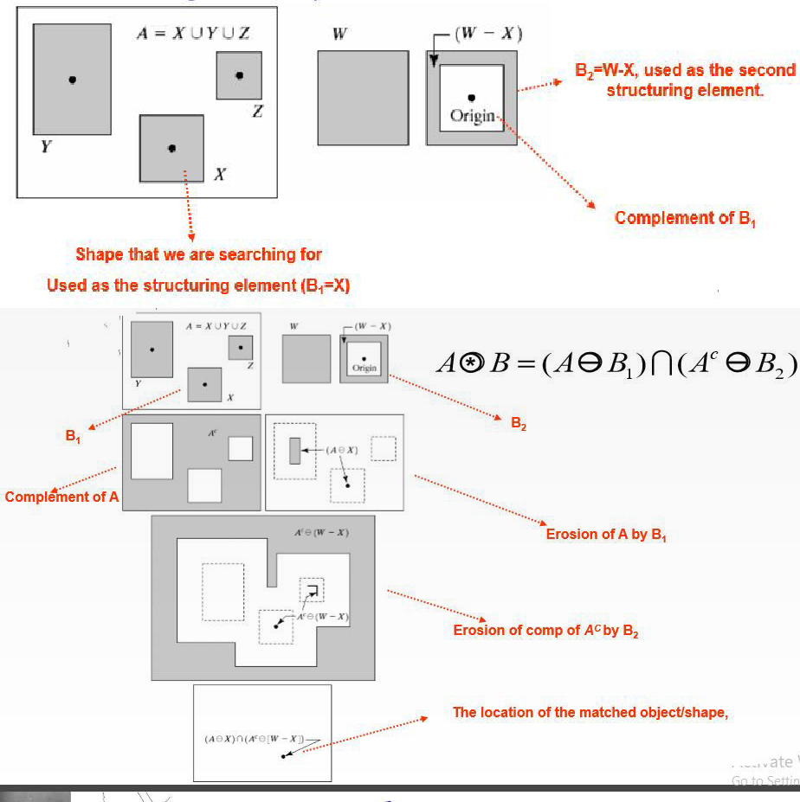

Three disjoint shapes denoted C, D, and E

A = C ∪D∪E

Objective: To find the location/origin of one of the shapes, say D.

Origin/location of each shape given by its center of gravity.

Let D be enclosed by a small window W.

Local background of D deﬁned by the set di฀erence (W −D). Note

that D and W −D provide us with the two disjoint ses D∩(W −D) = ∅

1. Compute Ac



1. Compute
2. Compute
3. Set of locations where D exactly fits inside A is

The exact location of D

If B is the set composed of D and its background, the match of B in A is given by



The above can be generalized to the composite se being defined by B = (B1,B2) leading to



B1 is the set formed from elements of B associated with the object; B1 = D and

B2 = (W −D)

A point z in universe A belongs to the output if (B1)z ﬁts in A (hit)

and (B2)z misses A

* + 1. **Some basic morphological algorithms**

These algorithms are useful in extracting image components for representation and description of shape.

**Boundary extraction:**

Boundary of a set A is Denoted by β(A), can be obtained by first eroding A by a suitable structuring element B and computing set difference between A and its erosion.



**Ex1:** 3*3 structuring element is used for boundary extraction

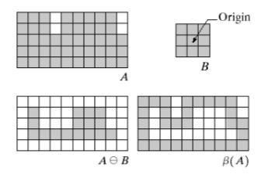

**Ex 2:** same 3*3 structuring element is used in this example also

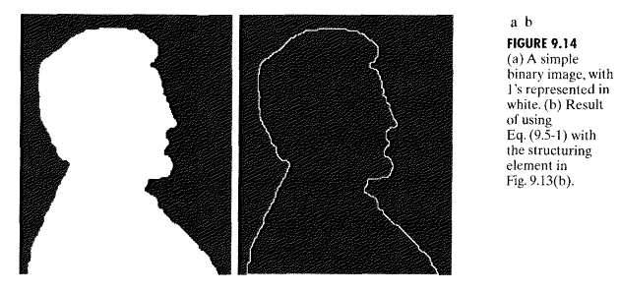

**Note**: That thicker boundary can be obtained by increasing the size of structuring element.

**Region Filling/Hole ﬁlling:**

We develop a simple algorithm for region filling based on set dilations, complementation and intersection.

Region filling can be performed by using the following definition. Given a symmetric structuring element B, one of the non-boundary pixels (Xk) is consecutively diluted and its intersection with the complement of A is taken as follows:

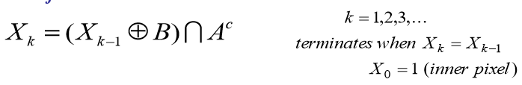

* Let A be a set whose elements are 8-connected boundaries, each boundary enclosing a background (hole).Given a point in each hole, we want to fill all holes.
* Start by forming an array X0 of 0s of the same size as A. The locations in X0 corresponding to the given point in each hole are set to 1.Let B be a symmetric SE with 4-connected neighbours to the origin as shown in the following figure.
* Where X0=P, and B is the symmetric structuring element. The algorithm terminates at iteration step k if Xk=Xk-1. The set union of Xk and A contains the filled set and its boundary.
* The dilation process would fill the entire area if left unchecked. However the intersection at each step with Ac limits the result to inside the region of interest it also called as *conditioned dilation*.

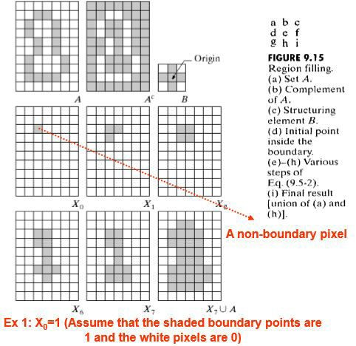

**EX2:**

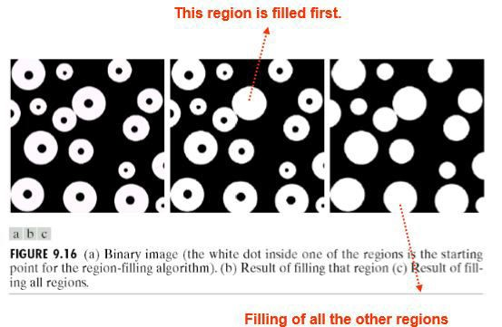

**Extraction of connected components:**

* Let Y represent a connected component contained in set A and assume that a point p of Y is known. Then the following iterative expression yields all the elements of Y:



* Where X0=p, and B is a suitable structuring element, as shown in the following figure. If Xk=Xk+1 the algorithm has converged and we let Y=Xk.
* The connected components finding equation and region filling equation both are similar. The only difference is the use of A instead of its compliment (Ac). This difference arise because all the elements sought (that is, the element of the connected component) are labelled 1.
* The intersection with A at each iterative step eliminates dilations centered on elements labelled 0.

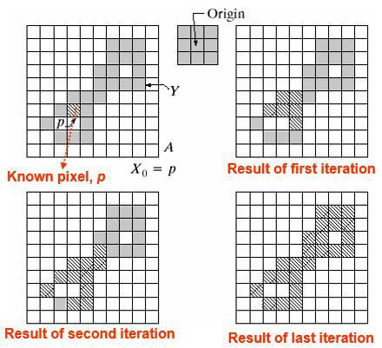

Example:

* X-ray image of chicken breast with bone fragments
* Objects of “signiﬁcant size” can be selected by applying erosion to the

thresholded image

* We may apply labels to the extracted components (region labeling)

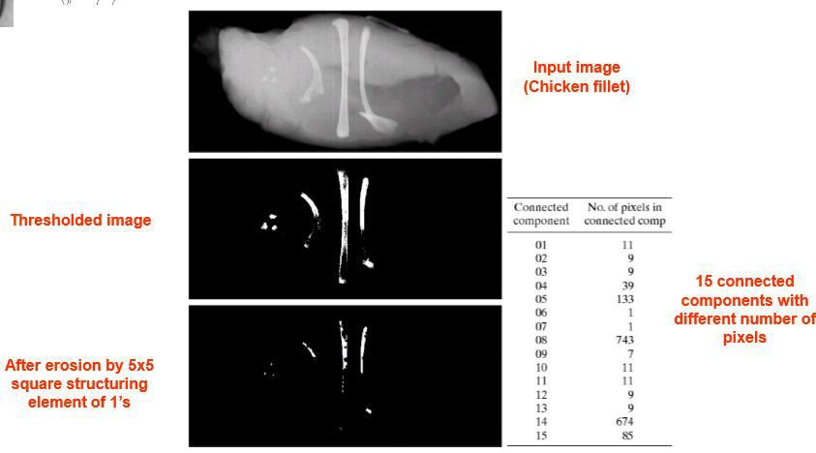

**Convex hull:**

* A set A is said to be convex set a Straight line segment joining any two points in A lies entirely within A.
* Convex hull H of an arbitrary set of points S is the smallest convex set containing S – Set di฀erence H −S is called the convex deﬁciency of S.
* Convex hull and convex deﬁciency are useful to describe objects.
* Algorithm to compute convex hull C(A) of a set A:
* Let Bi, i = 1,2,3,4 represent the four structuring elements in the ﬁgure·
* Bi is a clockwise rotation of Bi−1 by 90◦.
* Implement the equation i = 1,2,3,4 and k = 1,2,3,... with Xi 0 = A.
* Apply hit-or-miss with B1 till Xk == Xk−1, then, with B2 over original A, B3, and B4.
* Procedure converges when Xi k = Xi k−1 and we let Di = Xi k.
* Convex hull of A is given by

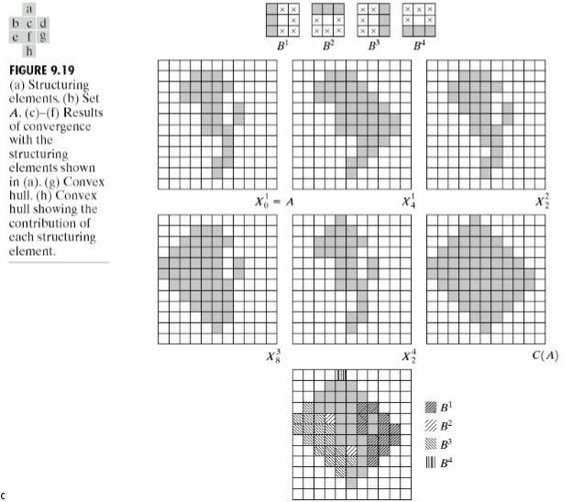

**Thinning:**

* Thinning of a set A by structuring element B is denoted by A⊗B, and can be find in terms of hit-or-miss transform:



* We are interested only in pattern matching with the structuring elements, so no background operation required in hit-or-miss transform. A more useful expression for thinning A symmetrically based on a sequence of structuring elements: {B} = {B1,B2,...,Bn} where Bi is a rotated version of Bi−1.using this concept, we now define thinning by a sequence of structuring elements as



* The process is to thin A by one pass with B1, then the result with one pass of B2, and so on, until A is thinned with one pass of Bn. The entire process is repeated until no further change s occur.

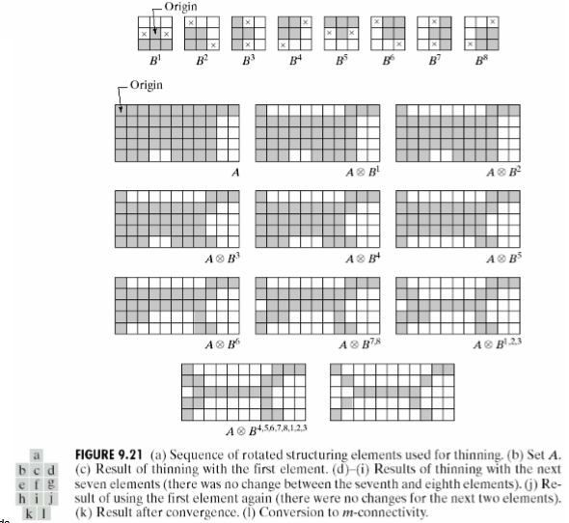

**Thickening:**

* Thickening is morphological dual of thickening and is defined by the expression:



* Where B is the structuring element suitable for thickening. As in thinning thickening can be defined as sequential operations.

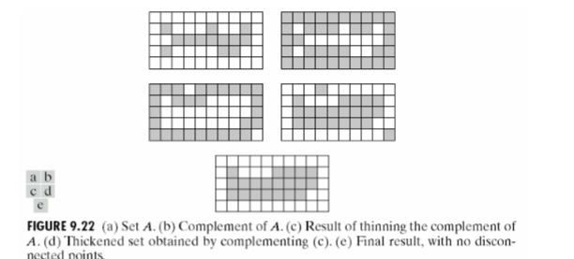

* The usual procedure is to thin the background of the set in question and then complement the result. In other words, to thicken a set A, we form C=Ac . Thin C, and then form Cc as illustrated in the above figure 9.22.

**Skeletons:**

* As shown in the following figure 9.23,the notation of a Skeleton, S(A), of a set A is intuitively simple. We deduce from this figure that

1. If z is a point of S(A) and (D)z is the largest disk centered at z and contained in A, one cannot ﬁnd a larger disk (not necessarily centered at z) containing (D)z and included in A. The disk (D)z is called a maximum disk.
2. Disk (D)z touches the boundary of A at two or more di฀erent places.

* Skeleton can be expressed in terms of erosions and openings. That is
* Where B is a structuring element, and indicates k successive erosions of A:

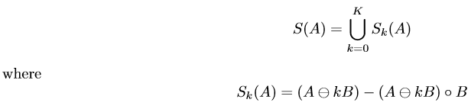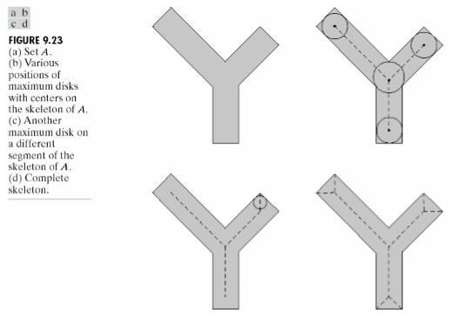



* K times and K is the last iterative step before A erodes to an empty set. In other words



* S(A) can be obtained as the union of skeleton subsets Sk(A). Also it can be shown that A can be reconstructed from the subsets using the equation

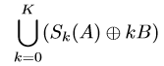

* Where (Sk(A)⊕kB) denotes k successive dilations of Sk(A). That is

(Sk(A)⊕kB) = ((...((Sk(A)⊕B)⊕B)⊕...)⊕B)

Example:

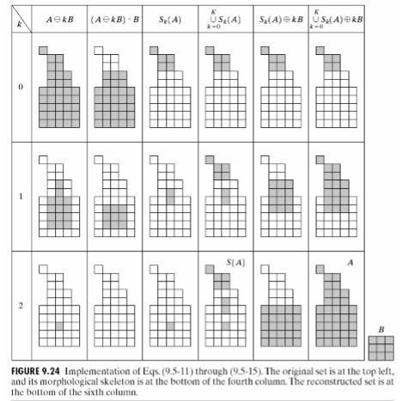

**Pruning:**

* Pruning methods are an essential complement to thinning and skeletonising algorithms because these procedures tend to leave parasitic components that need to be “cleaned up” by post processing.

A common approach in the automated reorganization of hand-printed characters is as follows.

* Analyze the shape of the skeleton of each character.
* Skeletons characterized by “spurs” or parasitic components.
* Spurs caused during erosion by non-uniformities in the strokes.
* Assume that the length of a spur or parasitic component does not exceed a speciﬁc number of pixels.

Figure 9.25 – Skeleton of hand-printed “a”

* Suppress a parasitic branch by successively eliminating its end point.
* Assumption: Any branch with ≤ 3 pixels will be removed.
* Achieved with thinning of an input set A with a sequence of SEs designed to detect only end points X1 = A⊗{B}

Figure 9.25d – Result of applying the above thinning three times.

* Restore the character to its original form with the parasitic branches removed.
* Form a set X2 containing all end points in X1

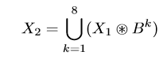

Dilate end points three times using set A as delimiter X3 = (X2 ⊕H)∩A where

H is a 3×3 se of 1s and intersection with A is applied after each step. The ﬁnal result comes from X4 = X1 ∪X3

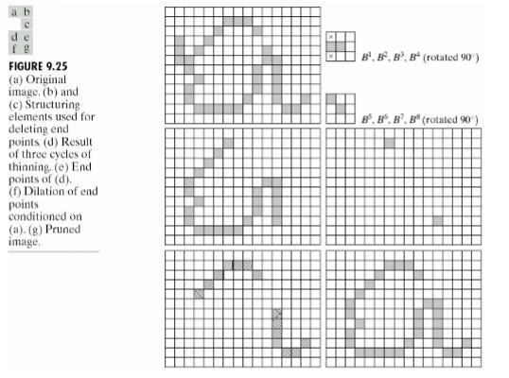

**UNIT-V**

**Assignment-Cum-Tutorial Questions Section - A**

|  |  |  |  |  |
| --- | --- | --- | --- | --- |
| ***Objective:***  **5.1 Preliminaries, Erosaion & Dialation and Opening & Closing** | | | | |
| 1. Smoothes the contour of | an | object, breaks | narrow isthmuses, | and |
| eliminate thin protrusions. |  |  | [CO-5 BL-2] | |
| a. Opening b. Closing |  | c. Dilation | d. Erosion |  |

1. _ _ eliminates small holes and gaps in the contour. [CO-5 BL-2]
   1. Opening b. Closing c. Dilation d. Erosion
2. We use morphological algorithms for _ [CO-5 BL-1]
   1. Extracting boundaries c. Connected components
   2. Convex hull, skeleton of the region d. All the above
3. Region filling is based on [CO-5 BL-2]
   1. Only the Set dilation c. Only the Set complementation
   2. Only the Set intersection d. All the three
4. Erosion of A by B, followed by a dilation of the result by B is_ [CO-5 BL-2]
   1. Opening A by B c. Closing A by B
   2. Opening B by A d. Closing B by A
5. Dilation of A by B, followed by the erosion of the result by B is _ [CO-5 BL-2]
   1. Opening A by B c. Closing A by B
   2. Opening B by A d. Closing B by A
6. First eroding A by suitable structuring element B and then performing the set difference between A and its erosion is_ _ operation [CO-5 BL-2]
   1. Boundary Extraction c. Region Filling
   2. Both d. None

**5.2 The Hit –or-Mis Transform & Basic Morphologic Algorithms**

1. If z is point of skeleton S(A) and (D)z is the largest disk centred at z and contained in A, one cannot find largest disk containing (D)z and include in

A. The disk (D)z is called_ _ [CO-5 BL-2]

* 1. mask disk
  2. large disk
  3. maximum disk
  4. grater disk

1. The maximum disk (D)z can touches the boundaries of at how many places?
   1. 1 b.0 c. 2 d. More than 2 [CO-5 BL-2]
2. Set A is said to be _ if the straight line segment joining any two points in A lies entirely within A. [CO-5 BL-2]

a. Convex b. Concave c. Both d. None

***Descriptive:***

**SECTION-B**

**5.1 Preliminaries, Erosaion & Dialation and Opening & Closing**

* 1. Explain Basic concepts from set theory on binary images in morphological image processing. [CO-5 BL-1]
  2. Explain Basic concepts from logical operations involving binary images in morphological image processing. [CO-5 BL-1]
  3. Describe Dilation and Erosion morphological transformations on a binary image. [CO-5 BL-2]
  4. Explain the opening operation in image morphology with examples?

[CO-5 BL-2]

* 1. Explain the closing operation in image morphology with examples?

[CO-5 BL-2]

**5.2 The Hit –or-Mis Transform & Basic Morphologic Algorithms**

* 1. Write about the importance of Hit-or-Miss morphological transformation operation on a digital binary image. [CO-5 BL-3]
  2. Explain boundary extraction and region filling process [CO-5 BL-3]
  3. Write the procedure for extraction of connected components [CO-5 BL-3]
  4. Explain convex hull [CO-5 BL-3]